A1099-Indus-Bowl-Naga-3000 BCE

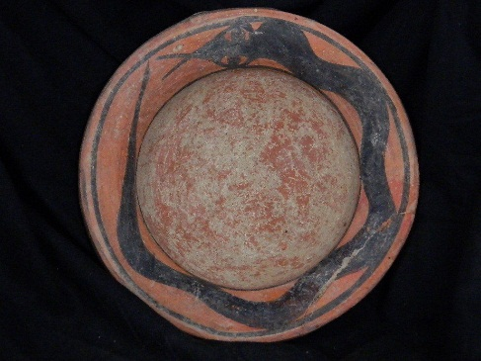 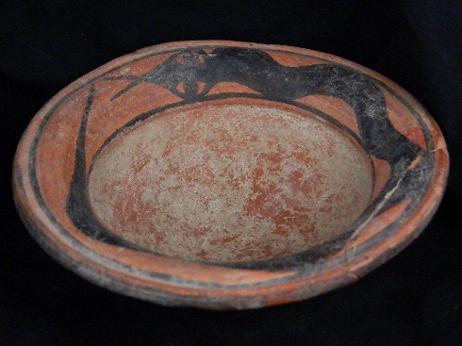 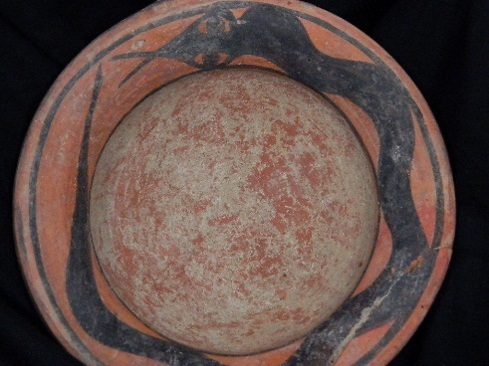

**Formal Label: Indus Valley Bowl with Encircling Naga, 3000 BCE**

**Case no.: 3**

**Accession Number: A1099**

**Formal Label: Indus Valley Bowl with Encircling Naga, 3000 BCE**

**Display Description:**

Kulli-Mehi Culture Ceramics dating to the “mature” Harappan Period, 3A (Harappa A Phase) c 2500 BCE are characterized by fine-line painting in black over a pinkish or buff ground, with an occasional dark red dark red vertical or horizontal band dividing zones. The Kulli-Mehi group is divided into two distinct types based on the style of decoration: 1)purely geometric designs and 2) geometric designs

combined with stylized animals and plants. It is probable that the second type developed out of the first. Animal and plant motifs are comparable to Nal culture types.

Nal Culture Ceramics also dating to the “mature” Harappan Period, 3A (Harappa A Phase) c 2500 BCE consist of wheel-made bowls and canisters with a distinctive ring base and sides with precise geometric drawings of animals and plants, which are infilled with red, green and yellow pigments. Pottery can have repeated motifs vertically divided by red bars outlined by black.

Of animal figurines, most are made from molds and feature Brahman bulls which are portrayed with long, curved horns, powerful muzzle, and large

round eyes. Distinctive black linear motifs are characteristic of the Kulli-Mehi Culture Ceramics.

**LC Classification:** DS425

**Date or Time Horizon:** 3000 BCE

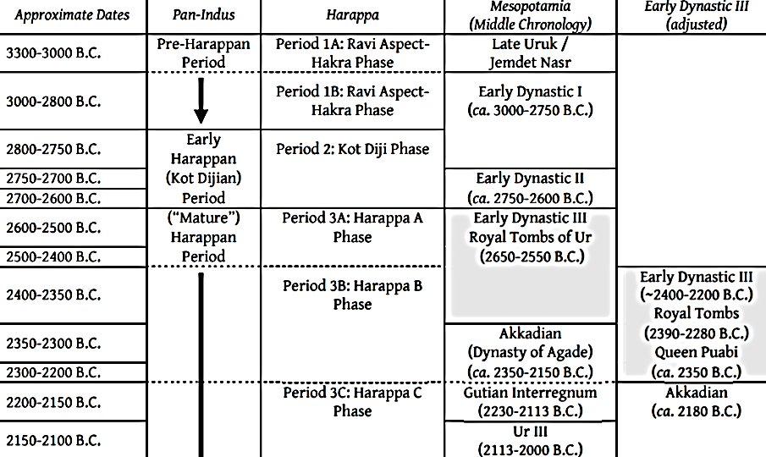

Fig. Comparison of the chronologies of the Indus Civilization and Mesopotamia (after Lamberg-Karlovsky & Sabloff 1995; Meadow, Kenoyer & Wright. 1998; 1999; 2001; Postgate 1995; Reade 2001).

**Geographical Area:** Indus Valley

**Cultural Affiliation:** Indus Civilization

**Medium:** Terracotta

**Dimensions:   
Weight:**

**Provenance: Ex European Collection, 1970-2016.**

**Condition:** Broken rim portion, glued

**Discussion:** The Sanskrit word *Naga* has its root *nag* the word for “serpent”. In Indian mythology, Nagas are primarily sub-marine serpent-beings. The encircling Naga is an emblem of the amphisbaenic serpent that resurrects its self by shedding its skin periodically. It symbolizes, in Jungian terms, the regeneration of a new trans-personal self from the limited human ego. This image contradicts the Judeo-Christian reading of the Adam and Eve encounter with the serpent in the Garden of Eden where this emergence of the new self is deemed a crime against Yahweh. This comparison of the two serpents and their impacts on the human psyche perfectly characterizes the difference between Eastern and Western views of spiritual enlightenment.

Therefore, this bowl would have been used in a ritual context that contained a libation of water that conferred upon the acolyte the blessings of the amphisbaenic Naga in the unfolding of the trans-personal self. In Hindu mythology this is expressed as the self-sacrifice of the primordial being for the sake of creating the world. In Christianity it is the self-sacrifice of the Christ for the salvation of humanity (Elder 2012: 46).

**References:**

# Dani, A.H. and [V.M. Masson](https://www.amazon.co.uk/s/ref=dp_byline_sr_book_2?ie=UTF8&text=V.M.+Masson&search-alias=books-uk&field-author=V.M.+Masson&sort=relevancerank). 1999. *History of civilizations of Central Asia. 1, The dawn of civilization : earliest times to 700 B.C.* Delhi : Motilal Banarsidass.

Elder, George R. 2012. *The Snake and the Rope: A Jungian View of Hinduism*. Indianapolis, IN: Dog Ear Publishing, LLC.

# Semeka-Pankratov, Elena. 1979. “A semiotic approach to the polysemy of the symbol Naga in Indian mythology,” *Semiotica* 27(1979)1/3: 227 – 289.